**Name**:Fatma Sied Awwad Mohamed Elmasry

**B.N/**575

**Date**: 6-6-2021

**Topic**: Programming Languages

**Application Brief**:

I prefer this topic because I would like to become a programmer one day

**GitHub-Link:**

**GitHub-Page(Published Website):**

**Screenshots**:

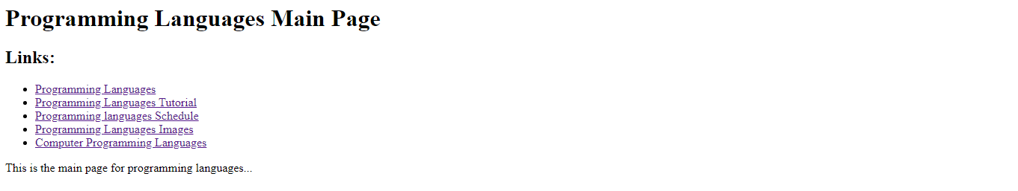

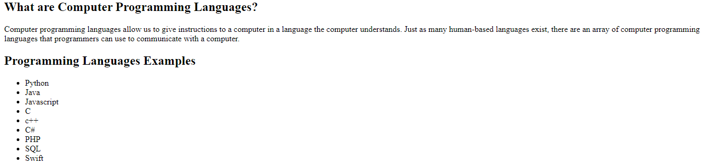



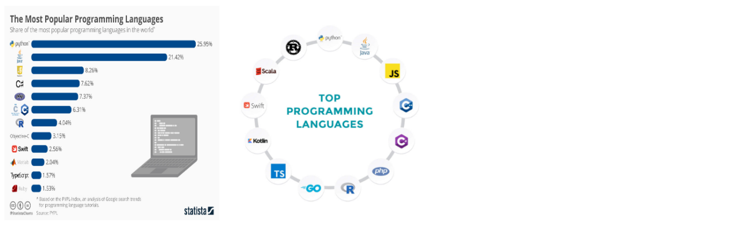

**Source Code**:

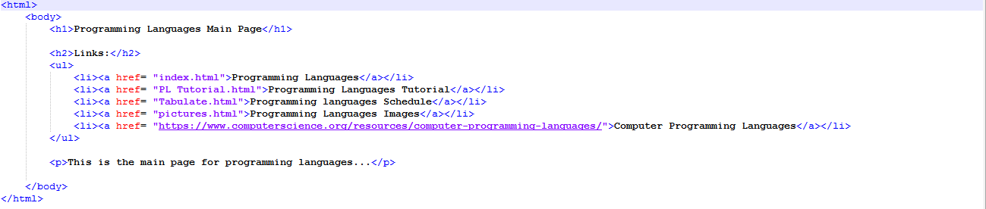

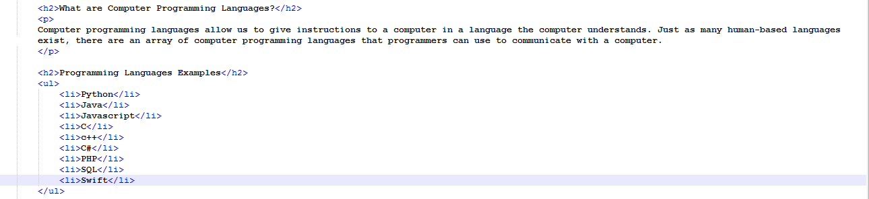

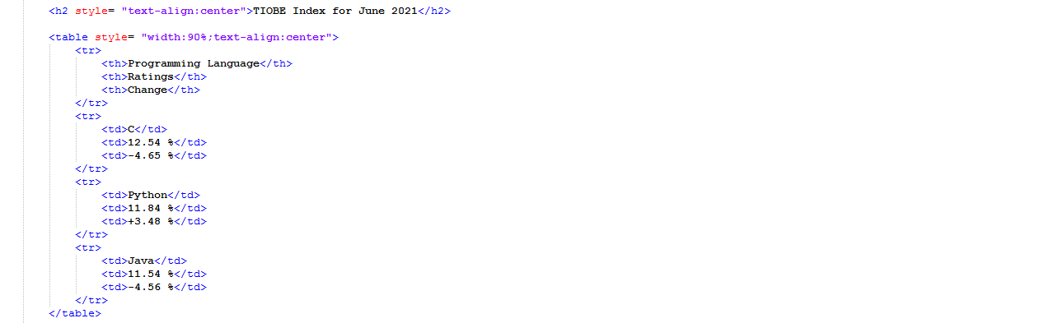

8